**Project Title:** Emerging Methods for Early Detection of Forest Fires **Project Design Phase-I** - **Solution Fit Template**

**Focus on J&P, tap into BE, understand RC**

**Team ID:** PNT2022TMID20340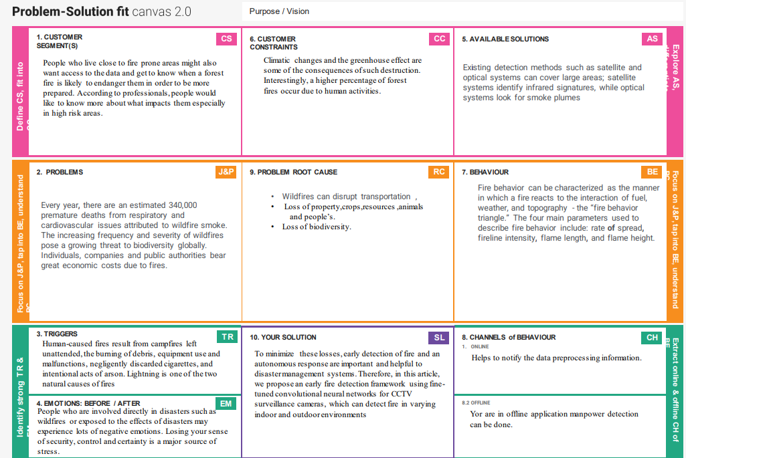

**Explore AS, differentiate**

**Deﬁne CS, ﬁt into CC**

|  |
| --- |
|  |

**Identify strong TR & EM**

**Identify strong TR & EM**